**Modern Wooden Shelf with Beach Ocean Resin Waves**

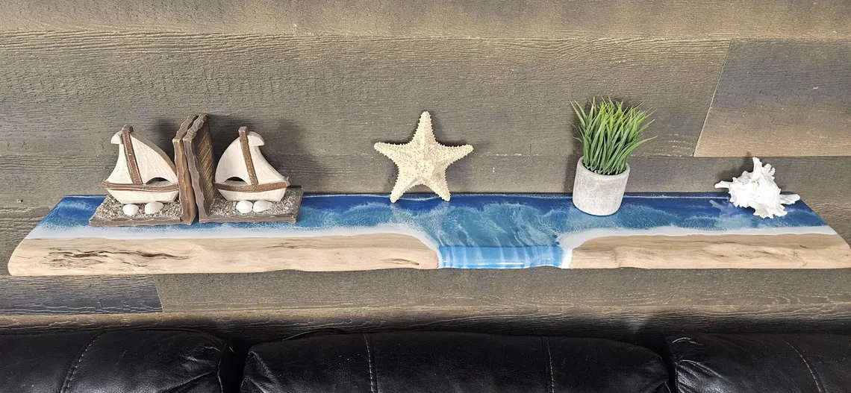A Modern Wooden Shelf with Beach Ocean Resin Waves is a stunning and unique piece that combines natural wood with the artistry of ocean-inspired resin waves. The shelf's wooden base typically features a sleek, minimalist design, while the resin waves, which mimic the movement and colors of the ocean, add a creative, coastal flair. The resin is often hand-poured to create a beautiful, smooth finish with shades of blue, turquoise, or white, resembling the serene flow of ocean waves. Perfect for those who love beach or coastal décor, this shelf serves as both a functional storage solution and a captivating piece of art, ideal for living rooms, bedrooms, or bathrooms looking to incorporate a touch of the sea into their interior design.

.